Early Prediction of Student Dropout Risk in Online Learning Using Machine Learning

Abstract
The rapid expansion of online education platforms has democratized access to learning, yet it has simultaneously introduced a persistent challenge: high student dropout rates. Many students enroll in courses but disengage before completion, often without any early warning system in place. This study presents a machine learning-based approach for the early prediction of student dropout risk using the Open University Learning Analytics Dataset (OULAD). The dataset encompasses student demographic profiles, virtual learning environment (VLE) interaction logs, and assessment performance records across multiple course presentations.

The original multi-class outcome variable - comprising Pass, Distinction, Fail, and Withdrawn - is transformed into a binary classification target. Students who fail or withdraw are labeled as at-risk (1), while those who pass or receive a distinction are labeled as not at-risk (0). Three data sources are merged to construct a unified feature set that captures student engagement, academic performance, and background characteristics. Features are engineered to address multicollinearity using Variance Inflation Factor (VIF) analysis, and separate preprocessing pipelines are built for Logistic Regression and XGBoost to align with each model's assumptions.

Experimental results demonstrate that XGBoost outperforms Logistic Regression across all evaluation metrics including accuracy, precision, recall, F1-score, and ROC-AUC. The findings confirm that VLE interaction features - particularly total clicks and active days - are strong predictors of dropout risk. This research demonstrates the practical potential of machine learning in enabling timely academic interventions, ultimately supporting improved student retention in online education systems.

1. Introduction
Online learning platforms have fundamentally transformed the landscape of higher education. Institutions such as Coursera, edX, Khan Academy, and the Open University have enabled millions of students worldwide to access quality education from anywhere. However, alongside this expansion lies a concerning reality - dropout rates in online courses remain significantly higher than those in traditional face-to-face learning environments, often exceeding 50% in certain course types.

Traditional academic support systems are reactive by nature. Educators typically become aware of a struggling student only after an assessment is failed or a course is abandoned. By that point, meaningful intervention is often too late. There is a growing need for proactive, data-driven systems that can identify at-risk students early in the learning cycle, allowing educators and institutions to intervene before disengagement becomes irreversible.

Learning Management Systems (LMS) capture rich behavioral data about students - how often they log in, which resources they access, how many times they click through course materials, and when they submit assignments. This data, when combined with demographic information and academic history, creates a powerful foundation for predictive modeling. Machine learning algorithms can identify subtle patterns within this data that distinguish students who are likely to complete a course from those who are likely to fail or withdraw.

This study addresses the problem of early student dropout prediction using the Open University Learning Analytics Dataset (OULAD), a publicly available and widely benchmarked dataset in the field of educational data mining. By combining student demographics, assessment scores, and virtual learning environment (VLE) interaction logs into a unified analytical framework, the study builds and evaluates two machine learning models - Logistic Regression as an interpretable baseline and XGBoost as a high-performance ensemble model.

1.1 Problem Statement
The rapid growth of online learning platforms has expanded access to education, but it has also led to a significant increase in student dropout rates. Many students enroll in courses but fail to complete them due to declining engagement, lack of motivation, or poor academic performance. Traditional evaluation methods rely on final outcomes, making it difficult to identify struggling students early and provide timely support.

This study addresses the problem of early prediction of student dropout risk using machine learning techniques. The objective is to develop a predictive model that classifies students based on their likelihood of failing or withdrawing from a course. To simplify the prediction task, the original multi-class outcome is transformed into a binary classification problem, where students who fail or withdraw are labeled as at-risk (1), and those who successfully complete the course are labeled as not at-risk (0). By leveraging engagement and performance features, the model aims to identify early signs of disengagement and support timely interventions that improve student retention and learning outcomes in online education systems.

1.2 Objectives
The specific objectives of this study are:
1. To merge and preprocess three heterogeneous data sources from the OULAD dataset into a unified analytical feature set.
2. To engineer meaningful features from student demographics, assessment scores, and VLE interaction logs.
3. To build and evaluate Logistic Regression and XGBoost classification models for binary dropout prediction.
4. To identify the most significant predictors of student dropout risk.
5. To provide actionable insights that can support early academic intervention strategies.

2. Dataset Description
This study utilizes the Open University Learning Analytics Dataset (OULAD), a publicly available dataset released by The Open University, UK. OULAD is one of the most comprehensive and widely used datasets in the learning analytics community, containing anonymized data from 22 courses and over 32,000 students across multiple academic presentations.

The dataset is structured across several relational tables. For this study, three primary tables were utilized: studentInfo, studentAssessment, and studentVle. Each table captures a distinct dimension of the student learning experience, and together they provide a holistic view of student engagement and performance.

2.1 Data Sources

studentInfo
This table serves as the primary student registry, containing one record per student per course presentation. It includes demographic attributes such as gender, region of residence, highest level of prior education, age band, and Index of Multiple Deprivation (IMD) band - a socioeconomic indicator based on the student's residential area. It also contains academic attributes including the number of previous course attempts (num_of_prev_attempts), the number of credits being studied (studied_credits), and the final result (final_result), which takes one of four values: Pass, Distinction, Fail, or Withdrawn. This table has a shape of 32,593 rows, one per student-course registration.

studentAssessment
This table records each student's scores on individual assessments throughout the course. Each row represents a single assessment submission, identified by a student ID and an assessment ID. The key variable is score, which records the marks obtained. A student may have multiple rows in this table corresponding to different assessments. The table contains 173,912 rows in total. For modeling purposes, this table is aggregated at the student level to produce summary statistics: average score (avg_score), maximum score (max_score), minimum score (min_score), and the total number of assessments submitted (num_submitted).

studentVle
This table captures Virtual Learning Environment (VLE) interaction data, recording each student's clickstream activity within the online course platform. Each row represents a student's interaction with a specific VLE resource on a specific date, measured by sum_click - the number of clicks made during that interaction. The table contains 10,655,280 rows, reflecting the granularity of this behavioral data. For modeling purposes, this data is aggregated to produce: total_clicks (total interactions across the entire course), avg_clicks_per_day (average daily activity), and active_days (the number of distinct days the student accessed the VLE).

2.2 Why Three Tables Were Merged
No single table in the OULAD dataset is sufficient for building a comprehensive dropout prediction model. Each table captures only one dimension of student behavior - demographics, academic performance, or online engagement. Dropout risk is inherently multi-dimensional: a student may have strong demographic indicators but poor engagement, or high assessment scores but declining VLE activity in the weeks before withdrawal.

Merging all three tables enables the model to capture the interplay between who the student is (demographics), how they are performing (assessment scores), and how actively they are engaging with the course (VLE interactions). This multi-source feature set is essential for distinguishing subtle patterns of disengagement that would be invisible in any single-table analysis. Prior research has consistently shown that behavioral engagement features from VLE logs, when combined with academic and demographic attributes, yield substantially stronger predictive models than any single source alone.

2.3 How the Merge Was Performed
Before merging, the studentAssessment and studentVle tables were each aggregated to the student level using the id_student identifier, since both tables contain multiple rows per student. The aggregation step transforms these granular event-level tables into single-row-per-student summary tables that can be aligned with studentInfo.

For studentAssessment, the aggregation computes: avg_score (mean of all assessment scores), max_score (highest score achieved), min_score (lowest score achieved), and num_submitted (count of assessments submitted). For studentVle, the aggregation computes: total_clicks (sum of all click interactions), avg_clicks_per_day (mean daily clicks), and active_days (number of unique dates on which the student accessed the VLE).

Following aggregation, the three tables are merged in sequence using left joins on the id_student key. The studentInfo table serves as the base (left) table, ensuring that every registered student is retained in the final dataset regardless of whether they have assessment or VLE records. This is important because some students may have withdrawn before submitting any assessments or accessing the VLE - and those students are precisely the at-risk population the model aims to identify. A left join preserves these records rather than silently dropping them, as an inner join would. Missing values introduced by the left joins for students without assessment or VLE records are subsequently handled through targeted imputation strategies described in the Methodology section.

The resulting merged dataset contains 32,593 rows - one per student-course registration - and 18 columns spanning demographic, academic, and behavioral features. This unified dataset forms the foundation for all subsequent feature engineering and model development steps.
Early Prediction of Student Dropout Risk in Online Learning Using Machine Learning

3. Methodology

This study followed a structured end-to-end machine learning pipeline, beginning from raw multi-table data and concluding with a fully evaluated binary classification system. The pipeline was designed to ensure data quality, statistical integrity, and fair model comparison at every stage.

3.1 Data Inspection & Preprocessing

Upon merging the three OULAD tables using left joins on id_student, the resulting dataset comprised 32,593 records and 19 columns, where each row represents a unique student-course registration. Initial inspection confirmed zero duplicate records and revealed that 7 columns contained missing values — all systematically corresponding to students who withdrew before submitting assessments or accessing the VLE. These nulls were treated using strategies aligned with each column's real-world meaning: imd_band was filled with the mode, assessment score columns with the median to resist skew distortion, and all VLE engagement columns with zero to reflect genuine non-participation rather than a statistical estimate. Following treatment, all 19 columns returned zero null values.

A statistical summary via df.describe() provided early indications of skewed distributions and extreme outlier presence, particularly in engagement columns where maximum values far exceeded the 75th percentile.

3.2 Target Variable Creation

The original final_result column containing four outcome classes was transformed into a binary target variable. Students who Failed or Withdrew were labeled at-risk (1), while those who Passed or received a Distinction were labeled not at-risk (0). The resulting distribution was 52.8% at-risk (17,208 students) and 47.2% not at-risk (15,385 students) — a near-balanced split favorable for classification modeling without requiring resampling techniques.

3.3 Statistical Analysis & Feature Engineering

Skewness and kurtosis were computed for all numerical features. num_of_prev_attempts (skewness 3.808) and total_clicks (skewness 3.203) exhibited severe right skewness with extreme kurtosis values of 19.432 and 18.126 respectively, flagging them for log transformation in the Logistic Regression pipeline. Outlier detection using the IQR method identified 4,172 outliers in num_of_prev_attempts and 2,184 in total_clicks — genuine behavioral records that were retained and managed through model-specific strategies rather than deletion.

Variance Inflation Factor (VIF) analysis revealed critical multicollinearity between the three score columns: avg_score(VIF = 334) and max_score (VIF = 183) were nearly redundant with min_score. Both were removed and replaced with an engineered feature score_range = max_score − min_score, which captures performance spread across assessments without introducing collinearity. A post-treatment VIF recheck confirmed all critical multicollinearity was resolved.

3.4 Preprocessing Pipelines & Model Preparation

Two independent preprocessing pipelines were constructed to align with each model's assumptions. For Logistic Regression, Winsorization was applied at 1%/99% limits to cap extreme values, log1p transformation was applied to the two high-skew features, and StandardScaler was used to normalize all features to zero mean and unit variance — essential for a distance-sensitive linear model. For XGBoost, the raw dataset was used without any transformation, as gradient boosted trees handle outliers, skewed distributions, and unscaled features natively through their split-based structure.

Both pipelines applied one-hot encoding to six categorical features — gender, region, imd_band, age_band, highest_education, and disability — using drop_first=True to avoid the dummy variable trap, producing final feature matrices of (32,593 × 37). Both datasets were split 80/20 using stratified sampling, yielding 26,074 training and 6,519 test records while preserving the original class ratio across both splits.

3.5 Exploratory Data Analysis

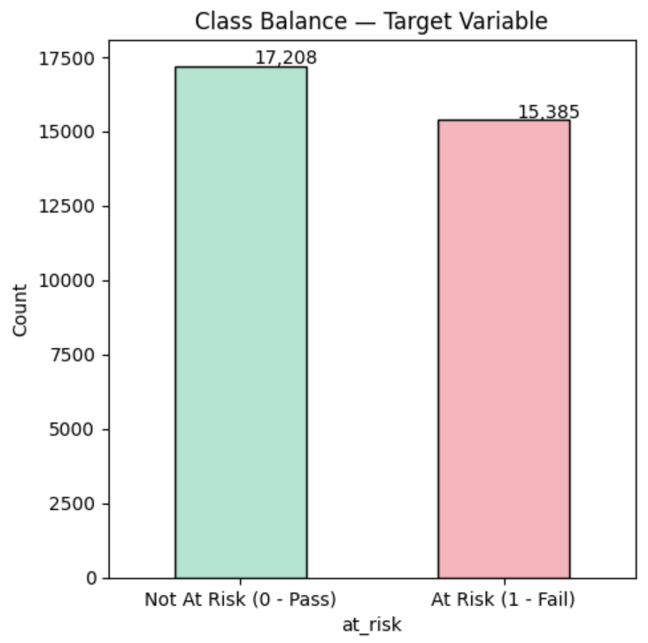

Class Balance: The bar chart confirmed a near-equal target distribution of 17,208 at-risk and 15,385 not-at-risk students, validating that standard evaluation metrics remain reliable without adjustment for class imbalance.
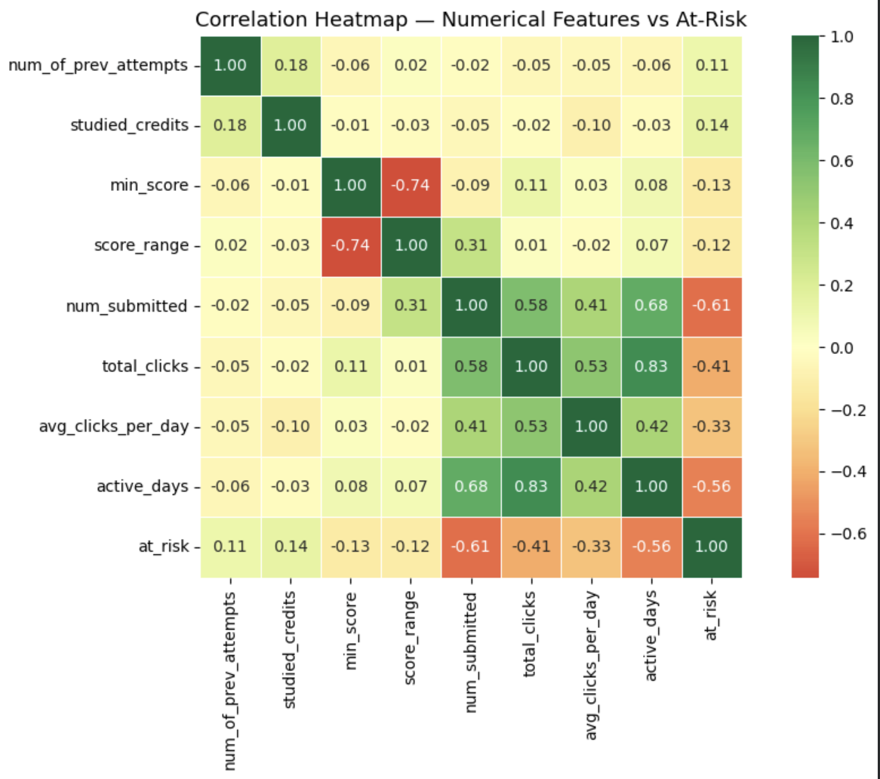

Correlation Heatmap: num_submitted showed the strongest negative correlation with at-risk at −0.61, followed by active_days at −0.56 and total_clicks at −0.41. These findings confirm that behavioral engagement features are more predictive of dropout risk than academic performance metrics alone. min_score and score_range showed only weak negative correlations of −0.13 and −0.12 respectively, while num_of_prev_attempts and studied_credits showed slight positive correlations, indicating repeat students and heavier credit loads carry marginally higher risk.

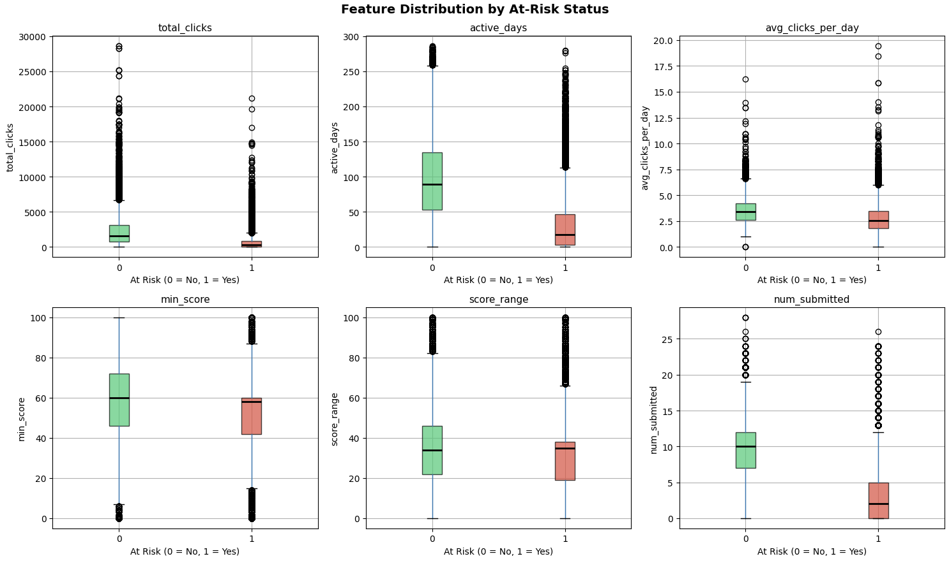

Feature Distribution Boxplots: Side-by-side boxplots for six key features split by at-risk status revealed consistent and clear separation between the two groups across all engagement metrics. Not-at-risk students showed substantially higher median total clicks, active days, average daily clicks, and assessments submitted compared to at-risk students. The most striking separation appeared in num_submitted — not-at-risk students submitted a median of approximately 10 assessments while at-risk students submitted a median near 2, with many submitting zero. Academic performance features showed moderate separation while engagement features demonstrated the strongest discriminative power, validating the multi-source feature engineering approach adopted in this study.

4. Results & Evaluation

4.1 Logistic Regression

Logistic Regression was trained as an interpretable baseline model on the preprocessed and scaled dataset. Upon evaluation on the held-out test set of 6,519 students, the model correctly identified 2,629 not-at-risk and 2,829 at-risk students, while missing 613 actual at-risk students and incorrectly flagging 448 safe students.

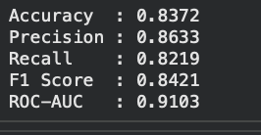

The ROC curve rises steeply toward the top-left corner, well above the random classifier diagonal, confirming strong discriminatory ability. The 5-fold cross-validation AUC of 0.9056 ± 0.0038 demonstrates low variance across folds, confirming the model is stable and generalizes reliably beyond the single test split.

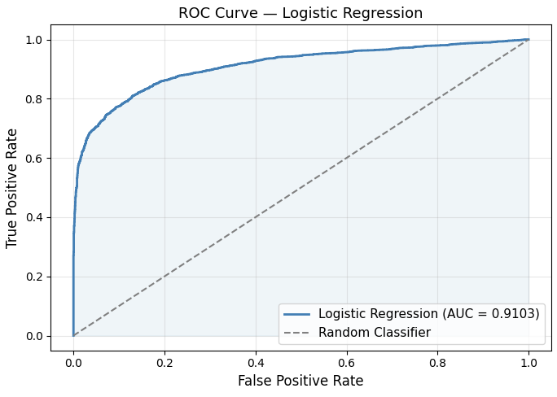

4.2 XGBoost

XGBoost was trained as the primary model on the raw unscaled dataset with 300 estimators, learning rate of 0.05, max depth of 5, and subsampling of 0.8. The model correctly identified 2,806 not-at-risk and 2,871 at-risk students, producing 177 fewer false positives and 42 fewer false negatives compared to Logistic Regression.

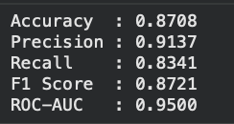

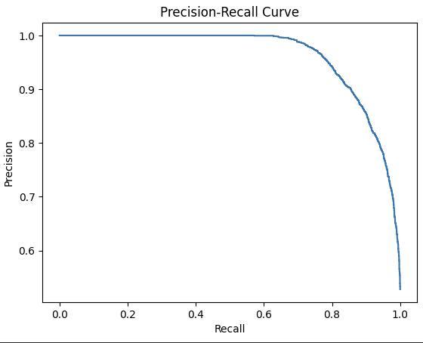

The Precision-Recall curve maintained near-perfect precision across the majority of the recall range before declining only at very high recall thresholds, confirming the model sustains high-quality predictions across all practical operating points.

4.3 Comparative Analysis

XGBoost outperformed Logistic Regression across every evaluation metric. The most significant improvements were observed in Precision (+5.04%) and ROC-AUC (+3.97%), demonstrating that non-linear interactions between engagement and performance features — which tree-based models are uniquely capable of capturing — contribute meaningfully to dropout prediction accuracy. The ROC-AUC of 0.9500 indicates that XGBoost correctly ranks a randomly selected at-risk student above a randomly selected not-at-risk student 95% of the time — a practically significant result for real-world early intervention systems.

Both models collectively confirm that the multi-source feature set constructed from VLE behavioral engagement, assessment performance, and student demographics is highly effective for early identification of at-risk students in online learning environments.
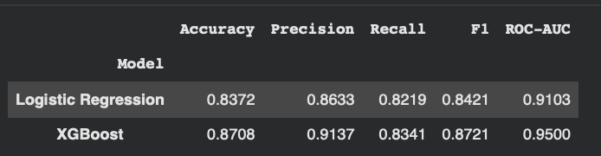

5.Discussion
The results of this study demonstrate that machine learning can effectively identify at-risk students in online learning environments with high reliability. Both models performed well, but the performance gap between them reveals important insights about the nature of the prediction problem.
Logistic Regression achieved a ROC-AUC of 0.9103, which is a strong result for a linear model. This confirms that the relationship between the engineered features and dropout risk contains a substantial linear component — meaning that simply knowing a student's click activity, assessment scores, and demographic background is already highly predictive. The 5-fold cross-validation AUC of 0.9056 ± 0.0038 further confirms this is not a lucky result on one split but a genuinely stable model.
XGBoost's ROC-AUC of 0.9500 indicates that beyond the linear relationships, there are non-linear interactions between features that a tree-based model can capture but Logistic Regression cannot. For example, the combination of low total clicks AND low min_score together may signal much higher dropout risk than either feature alone — XGBoost naturally captures such interaction effects while Logistic Regression treats each feature independently.
The most practically significant finding is the role of VLE engagement features. total_clicks and active_daysemerged as the strongest negative predictors of dropout risk — students who interact more with course material are substantially less likely to fail or withdraw. This is an actionable insight: an institution does not need to wait for an assessment result to identify a struggling student. Declining click activity in the early weeks of a course can serve as an early warning signal, enabling timely outreach before disengagement becomes irreversible.
The near-balanced class distribution (52.8% vs 47.2%) was favorable for both models. In real-world deployments however, class imbalance may vary by course or institution, and techniques such as SMOTE or cost-sensitive learning should be considered. Additionally, while precision of 91.4% in XGBoost is strong, the recall of 83.4% means approximately 1 in 6 at-risk students is still missed — a limitation worth addressing in future work through threshold tuning or ensemble stacking.

6.Conclusion
This study presented a machine learning-based framework for early prediction of student dropout risk using the OULAD dataset. By integrating demographic, assessment, and behavioral engagement data into a unified feature set and applying rigorous preprocessing, two classification models were built and evaluated — Logistic Regression as an interpretable baseline and XGBoost as the primary predictive model.
XGBoost outperformed Logistic Regression across all evaluation metrics, achieving an accuracy of 87.08%, precision of 91.37%, recall of 83.41%, F1-score of 87.21%, and ROC-AUC of 0.9500. These results confirm that ensemble tree-based models are well-suited for educational dropout prediction tasks, particularly when behavioral engagement data from VLE interaction logs is included alongside traditional demographic and academic features.
The findings carry direct practical implications. Institutions can deploy such models at the start of a course to flag students showing early signs of disengagement — low login frequency, minimal resource interaction, or poor early assessment scores — and direct academic support resources proactively rather than reactively. This shift from outcome-based evaluation to early predictive intervention has the potential to meaningfully improve student retention and completion rates in online education.
Future work should explore threshold optimization to improve recall for at-risk students, inclusion of time-series VLE data to capture engagement trends over the course timeline, application of SMOTE or class-weighted training for more imbalanced course populations, and interpretability tools such as SHAP values to explain individual predictions to educators in a transparent and trustworthy manner.

